
DK-Technologies A/S
Marielundvej 37D
DK-2730 Herlev
Denmark

PT 5664
Digital & Analog Component/
Composite WFM

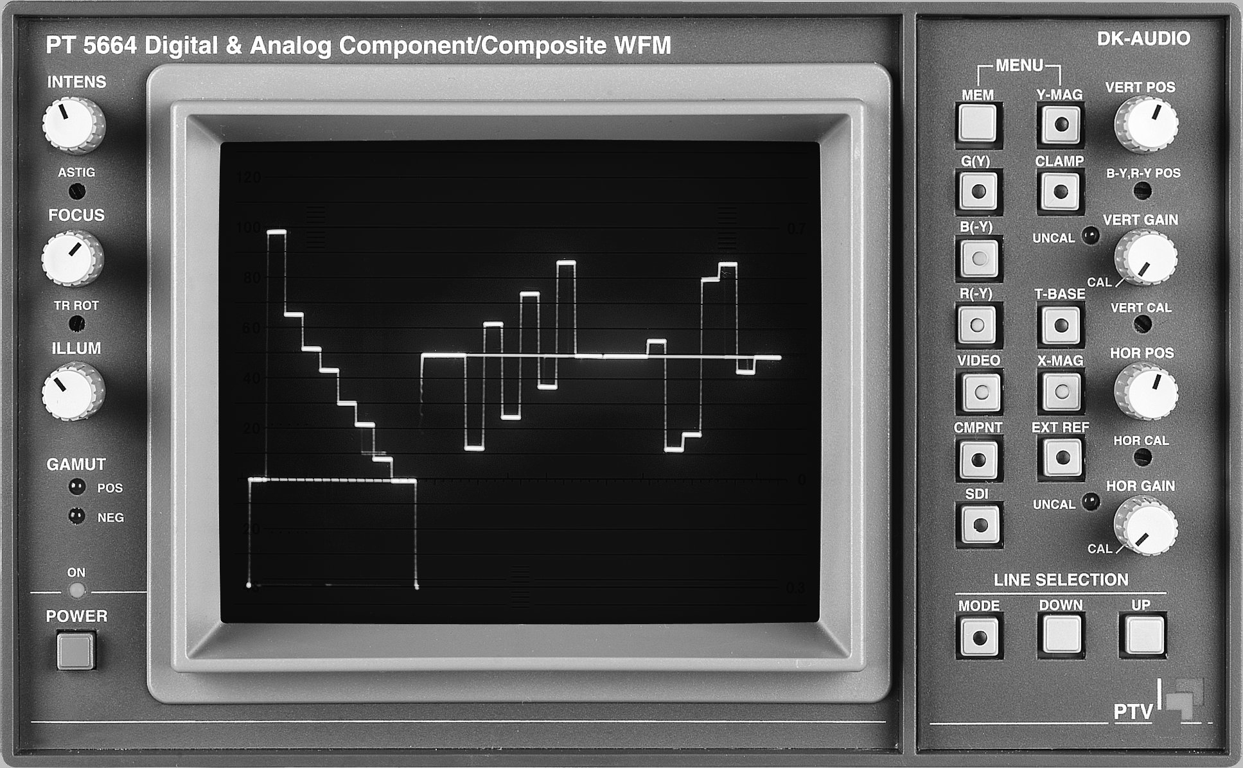

User’s Manual

PT 5664 Digital & Analog Component/Composite WFM | Total number of pages: 46

Copyright © 2003 | DK-Technologies A/S, Denmark  All Rights Reserved
Printed in Denmark 2003-09-09
Revision: 5
Publication number: 9499 491 10111

Contents

1 Safety 1-1
1.1 Introduction 1-1
1.2 Safety Precautions 1-1
1.3 Caution and Warning Statements 1-1
1.4 Impaired Safety Protection 1-1
1.4.1 Technical Specifications 1-1
1.4.2 Equipment Ratings 1-2
1.5 Electrostatic Sensitive Devices 1-2
1.6 Symbols 1-3
2 Introduction and Applications 2-1
2.1 General 2-1
2.2 Applications 2-2
2.2.1 WAVEFORM mode 2-2
2.2.2 PARADE mode 2-2
2.2.3 STAR mode 2-2
2.2.4 VECTOR mode 2-2
2.2.5 BOW TIE mode 2-3
2.2.6 TEST mode 2-3
3 Product Data 3-1
3.1 Safety characteristics 3-1
3.2 Performance characteristics 3-1
3.3 Versions 3-1
3.3.1 Options 3-1
3.4 Video Input selection 3-1
3.5 Serial Digital Video 3-2
3.6 Analog Video inputs 3-2
3.7 External reference input 3-2
3.8 Pix monitor output 3-3
3.8.1 RGB mode 3-3
3.8.2 Colour difference mode 3-3
3.8.3 Gamut error detector 3-3
3.9 Filters 3-3
3.9.1 NON-LINEARITY 3-4
3.10 Vertical amplifier 3-4
3.10.1 Deflection sensitivity 3-4
3.11 Clamp 3-4
3.12 Calibrator 3-4
3.12.1 Time calibration 3-4
3.12.2 Amplitude calibration 3-5
3.13 Horizontal system 3-5
3.13.1 Time base 3-5
3.13.2 Parade display 3-6
3.13.3 Bowtie display 3-6
3.14 X-Y displays 3-6
3.14.1 Vector display 3-6
3.14.2 Star display 3-6
3.15 Environmental conditions 3-6
3.15.1 Temperature range 3-6
3.15.2 Mechanical requirements 3-7
3.16 Power supply 3-7
3.17 Mechanical data 3-7
4 Accessories & options 4-1
4.1 Accessories 4-1
4.2 Options 4-1
5 Installation 5-1
5.1 Initial inspection 5-1
5.2 Safety instruction 5-1
5.2.1 Earthing 5-1
5.3 Mains voltage setting and fuses 5-1
5.4 Configuration 5-2
5.4.1 Formats 5-2
5.4.2 Input format selection. 5-2
5.4.3 Gamut indicator 5-3
5.4.4 External reference input 5-3
5.5 Rack mounting 5-4
5.5.1 Free air convection 5-4
5.5.2 Forced circulation 5-4
6 Operating Instructions 6-1
6.1 Front panel controls 6-1
6.2 Rear panel connections 6-4
6.3 Main MENU (MODE) selection 6-6
6.3.1 Input format 6-6
6.4 WAVEFORM display mode 6-7
6.4.1 WFM Display format 6-8
6.5 PARADE display mode 6-8
6.6 STAR display mode 6-9
6.6.1 Transcoder display 6-11
6.7 VECTOR display mode 6-12
6.7.1 Transcoder display 6-12
6.7.2 TEST GRID facilities 6-12
6.8 BOWTIE display mode 6-14
6.9 TEST mode 6-15
6.10 Line selection 6-16
6.10.1 General 6-16
6.10.2 Waveform mode 6-17
6.10.3 Vector mode 6-17
6.11 Gamut error detection 6-17
6.12 Master reset of the PT 5664 6-18
6.13 Memory functions 6-18
6.13.1 Front panel controlled memories 6-18
6.13.2 Remote controlled memories 6-19

Safety
Read this chapter carefully before installation and use of the instrument.

Introduction
The instrument described in this manual is designed to be used by properly trained personnel only.

Adjustment, maintenance and repair of the exposed equipment shall be carried out only by qualified personnel who are aware of hazards involved.

Safety Precautions
For the correct and safe use of the instrument, it is essential that both operating and servicing personnel follow generally accepted safety procedures in addition to the safety precautions specified in this manual. Specific warning and caution statements, where applicable, are found throughout this manual. Warning and caution statements and/or symbols are marked on the instrument where necessary.

Caution and Warning Statements
Caution
Used to indicate correct operation or maintenance in order to prevent damage to, or destruction of equipment or other property.

Warning
Used to indicate a potential hazard that requires correct procedures or practices in order to prevent personal injury.

Impaired Safety Protection

Technical Specifications
This manual provides technical information important for safe operation of the equipment.

Please refer to the Chapter Product Data for information regarding technical specifications and the Chapter Installation and Operating Instructions regarding instructions for use.

Technical assistance may be obtained from your local DK-office or from:

DK-TECHNOLOGIES A/S
Marielundvej 27
DK-2730 Herlev
Denmark
Phone: +45 4485 0255
Fax: +45 4485 0250
E-Mail: info@dk-audio.com
Website: http://www.dk-technologies.com

Equipment Ratings
The instrument can be used with a mains voltage supply of:
Voltage:
90 V AC - 250 V AC.
Frequency:
48 – 65 Hz.
The power consumption:
Does not exceed 72 VA.

The instrument is designed for the following environmental conditions:
Indoor use
Altitudes up to 2000 m
Temperatures between 5ºC and 40ºC
Maximum relative humidity of 80% for temperatures up to 31ºC decreasing linearly to 50% relative humidity at 40ºC.

The instrument is equipped with a number of input and output terminals as described in the Chapter Product Data.

The terminals are protected from becoming hazardous live by means of basic insulation and protective screening.

Whenever it is likely that safe operation is impaired, the instrument must be made inoperative and secured against unintended operation. The appropriate servicing authority must be informed.

For example, safety is likely to be impaired if the instrument fails to perform the intended measurements or shows visible damage.

WARNING: Protection provided by the equipment may be impaired, if the equipment is used in a manner not specified by this manual.


ATTENTION

Electrostatic Sensitive Devices
All ICs and many other semi-conductors are susceptible to electrostatic discharges ESD). Careless handling during repair can reduce lifetime drastically.

When repairing, make sure that you are connected to the same potential as the mass of the set via a wrist wrap with resistance. Keep components and tools also at this potential.

Symbols
Symbol | Colour: | Explanation:
 | Red | High voltage terminal: a terminal at which a voltage, with respect to another terminal or parts exists or may be adjusted to 1000 V or more. (High voltage > 1000 V).
 | Black/Yellow | Live part shock risk of electric shock.
 | Black/Yellow | To preserve the instrument from damage the operator must refer to an explanation in the instruction manual.
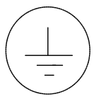 | White/Black | Protective earth (grounding) terminal.
~ | Black | Alternating current (placed on the identification plate).
 | White/Black | Off (supply - mains switch).  On (supply - mains switch).

Introduction and Applications

General
The PT 5664 Digital & Analog component/composite WFM is a multiformat waveform monitor and vectorscope for digital and analog component signals. Pushbuttons on the front enable switching between the display of SDI or analog component.

The PT 5664 automatically adjusts to 525-lines or to 625-lines system.

PT 5664 covers the following input formats:
- SDI (serial Digital Component)
- Y, P_{B}, P_{R} (analog component, SMPTE/EBU format)
- RGB
- BETACAM, 3-wire
- M II, 3-wire
- M II, 2-wire (only Waveform mode)
- Composite video signals

It provides the well-known display for both the analog component and digital SDI signals, i.e. waveform, parade, vector, star etc.

In the waveform and parade the display format is selectable between the YP_{B}P_{R} or RGB display.

The PT 5664 has the following inputs:
- One SDI input
- One set of analog component inputs
- One Analog Composite input
The inputs are selectable by means of pushbuttons on the front.

The PT 5664 provides the following outputs:
- The digital interface provides a re-clocked and cable equalised SDI output of the incoming SDI signal
- The PIX-monitor output is a RGB output for monitoring purpose only

SDI and YP_{B}P_{R} inputs are automatically converted to the RGB format. The output has also overlay of the gamut detection, indicating visually where the colour space has been violated.
A violation of the colour space is also indicated with the Gamut LED’s on the front plate.

Main functions are directly accessible by means of pushbuttons, while format settings and more special features are menu-controlled.

Applications
The PT 5664 digital & analog component/composite waveform monitor is designed for alignment and monitoring of signals in analogue component and composite based environments such as TV studios and OB vans (outside broadcasting), Production houses etc.

For this application the following display-modes are available:
- WAVEFORM
- PARADE
- STAR
- VECTOR
- BOWTIE
- TEST

WAVEFORM mode
In WAVEFORM mode the SDI signal or the analog component signals can be displayed as represented by their individual components.

The WAVEFORM mode also has the possibility to overlay the signals in either SDI or analog component. Two or three components can be displayed overlaid onto each other. When the composite video input is selected, one component can additionally be selected to produce a component/video overlay display. Waveforms can be shown in either H, 2H, V or 2V display.

PARADE mode
The PARADE mode shows the three component-/colour difference signals side by side, either from the SDI input or from the analog component input.

In Y/P_{B}/P_{R} display mode the P_{B}/P_{R} components are clamped to the 50% level on the screen.

When the Video Input is selected, one (selectable) component signal is shown together with the video signal in the parade display. H- as well as V-mode can be chosen.

STAR mode
With the STAR mode, timing and amplitude errors between the components of the signal, can be monitored using a plain colourbar as reference signal.

Component based signals from sources such as a VTR or camera are particularly sensitive to timing and amplitude errors in the signal path. A timing error results in coloured edges and an amplitude error results in discolouring of the picture. The Star display in magnified mode is designed especially to reveal such errors. To ensure a correct alignment, measuring dots can be switched on, to facilitate the detection of timing errors in the video signal.

VECTOR mode
The VECTOR mode shows the colour phases and amplitudes of the component signals.

BOW TIE mode
The Bow tie measurement is used for alignment of amplitude and timing in studio systems, but for this measurement a special test signal is needed. With this special signal higher accuracy can be obtained than with the STAR display.

TEST mode
Several test facilities for the alignment of studio equipment are available:
- 700mV test display.
This function shows a fixed indication of the 700 mV level.

- Variable off-set test display
Indicates a selected level on the display. The selected level is shown in mV on the display. The level can be varied from –500 mV to +1500 mV.

- 100kHz square wave display
To check the horizontal timing and the vertical deflection in Waveform mode, a 100 kHz square wave signal with amplitude of 1V_{PP} is provided from an internal generator.

- G(Y) & EXT reference ALT display
This mode offers a waveform display of the G(Y) component signal alternating with the external reference signal. This gives the possibility to check the timing between the two signals.

- G(Y) – EXT
This mode offers a waveform display of the subtraction between the G(Y) component and the external reference signal. The feature offers the possibility to check the timing between the two signals.

- EXT
Shows the signal applied at the EXTERNAL REF connector.

Product Data

Safety characteristics
This apparatus has been designed and tested in accordance with Safety Class I requirements of IEC publication 348 (Safety requirements for Electronic Measuring Apparatus), and has been supplied in a safe condition. This manual contains information and warnings, which must be followed to ensure safe operation and to retain the apparatus in a safe condition.

Warning: For safety reasons PT 5664 must be mounted in one of the cabinets PM 8539,
PM 8541 or PM 8543. The PT 5664 must only be installed by use of the screws and washers mounted on the rear plate of the instrument to obtain a safe condition before it is switched on.

Performance characteristics
Properties expressed in numerical values with stated tolerances are guaranteed by DK-Audio. Specified non-tolerance numerical values indicate those that could be nominally expected as a mean of a range of identical instruments.

Versions
The PT 5664 automatically adjusts to the correct television system. If the system is non-interlaced (like 524 or 624 line) this will be indicated as by an “NI” on the screen.
The Graticule is universal for 0-700mV component signals and has specific markings for analog composite video in 625-lines. The built-in transcoder is a SMPTE/EBU type, which converts SDI (and 625-lines BETACAM) into correct RGB values.

Options
PM 8539 19" rack cabinet
PM 8540 Blind plate for PM 8539
PM 8541 Carrying case
PM 8542/20 Interface cable for connection to PM 5667/PM5668
PM 8543 Cabinet, plain

Video Input selection
The SDI input, analog component video inputs and the composite video input on the rear panel can be selected from the front panel for display on the CRT.
The component channels can be switched on/off individually and one input can be substituted with the composite video input.

Serial Digital Video
According to standards: SMPTE259M and ITU-656.

SDI Input:
- Return loss: >15 dB, 5-270 MHz
- Cable Equalisation: 0-300m typical, @Belden 8281
- Display formats: as for analog YP_{B}P_{R,} The composite input can be selected for display as
one of the channels
SDI output:
- Return loss: >15 dB, 5-270 MHz
- Rise Time: 600 ps typical
- Jitter: ±250 ps typical (with 250 ps input jitter)

Analog Video inputs
The analog component video inputs can either be in the YP_{B}P_{R} or in the RGB format. The composite input can be selected for display as one of the channels.

Input 1: G or Y
Input 2: B or B-Y
Input 3: R or R-Y
Input 4: Composite video
Note:
The colour difference signals B-Y and R-Y equals the P_{B} and P_{R} signals respectively.
- Connector: 8 x BNC
- Impedance: High Ohmic, 75Ω looped through
- Return loss: >40 dB up to 7 MHz
- Max. input: 2 V_{PP} AC, less than -2/+6 VDC
- Gain difference between inputs: <1% at 0.5 MHz and at 5 MHz
- Timing error between inputs: <5 ns
- Crosstalk between inputs: Better than –70 dB at 5 MHz
- Crosstalk from non-selected input to screen: Better than –46 dB up to 5 MHz

External reference input
The time base, the sequence switch, and the clamp pulse generator are locked to the sync information from input, G(Y), the composite input, or the external reference input. Selection of the reference input internal or external is done by a front panel push button.
- Signal requirement: Composite sync 150mV to 4V (internal selectable, see section 5.4.4) or composite video nominal level 6dB
- Connector: 2 x BNC
- Impedance: High ohmic, 75Ω looped through
- Return loss: Better than 40 dB up to 7 MHz
- Max input signal: 5 V_{PP}AC, less than ±2 VDC
- Superimposed hum: Less than 1 V_{PP}
- Crosstalk between EXT REF and inputs G(Y), B(-Y), R(-Y): Better than –60 dB at 5 MHz

Pix monitor output
This output is always in RGB format. If the input is colour difference signals (formats such as SDI, Y/P_{B/}P_{R,} MII, or Betacam) an automatic transcoding to RGB format takes place. A gamut detector monitors the RGB outputs to detect signal levels exceeding predetermined limits.
The gamut indication may be switched on/off by use of an internal programming plug, see section 5.4.3.
- Connector: 3 x BNC
- Impedance: 75Ω
- Return loss: Better than 34 dB up to 6 MHz

RGB mode
- Gain ratio: Within 0.3 dB
- Frequency response: 50 kHz to 6 MHz within 0.5 dB

Colour difference mode
- Gain accuracy: Within 0.3 dB
- Frequency response: 50 kHz to 6MHz within 1 dB

Gamut error detector
Band limitation ensures that very short aberrations with low amplitude in the video signal does not trigger the gamut detectors.
- Bandwidth of detectors: Approx. 1 MHz

- Lower limit preset: -35 mV ±5 mV
- Upper limit preset: 735 mV ± 5 mV

Filters
Filters for frequency response change are selectable by menu operation.

FLAT:
Amplitude response (analog inputs):
- 50 kHz to 6 MHz: Within ± 2%
- 6 MHz to 10 MHz: Within +2% to -10%
- Smooth roll-off above 6 MHz

Amplitude response (SDI inputs):
- 50 kHz to 5.75 MHz: Within ± 2%
- Above 5.75 MHz fast attenuation

LOW PASS:
Amplitude response:
- Attenuation less than 3 dB at 1 MHz ± 0.1 MHz, more than 26 dB at f_{SC}

NON-LINEARITY
Amplitude response:
- Bandpass filter, centre frequency at 325 kHz with increased gain to obtain 280 mV_{PP} spikes from 140 mV riser in staircase
- Inherent error: Less than 0.25%

Vertical amplifier

Deflection sensitivity
- Video input: 1 V full scale ± 1%
- 5x magnifier: 0.2 V full scale ± 2%
- Max deflection (Y-MAG off): 2 x screen height
- Vertical positioning (Y-MAG off): 3 x screen height
- Gain range: Fixed gain +3 dB to -11.5 dB

The following specifications apply to the display of 1V video signal through the video inputs, when the gain is 1V full scale, no filters selected, and clamp on:
- 2T k-rating: Better than 0.25%
- 2T pulse to bar ratio: Better than 100% ± 1%
- Bar tilt: Less than 1%
- Field square wave tilt: Less than 0.5%

Clamp
The slow clamp (DC-restore) can be switched on and off by a front panel push button and has barely any attenuation of superimposed hum. This means that the clamp is slow enough to let hum pass to the display for monitoring:
- Hum attenuation: Less than 1 dB
- Black level shift due to change in APL from 10% to 90%: Less than 10 mV

Calibrator
The calibration generators can be activated in TEST mode by menu operation.

Time calibration
100 kHz SQUARE WAVE SIGNAL:
- Frequency: 100 kHz ± 100 Hz crystal controlled
- Amplitude: 1 V_{PP} ± 2%
- G(Y) & EXT. ALT: Input G(Y) and external reference signals superimposed
- Timing error between G(Y) input and external reference: Less than 10ns
- G(Y) - EXT.: Input G(Y) and external reference signals subtracted
- Accuracy: Better than 3%

Amplitude calibration
700mV FIXED:
- Signal type: Half sweep rate square wave; selectable superimposition on input signal G(Y), B(-Y), R(-Y), or composite video
- Amplitude: 700 mV ± 1%
VARIABLE:
- Signal type: Half sweep rate square wave; selectable superimposition on input signal G(Y), B(-Y), R(-Y), or composite video
- Amplitude range: -500 mV to +1500 mV in 1mV steps
- Amplitude accuracy: ±1% of reading ±1mV (±1 digit)

Horizontal system

Time base
ALL LINES:
1 V: Equal to field rate
2 V: Equal to frame rate.
1 H: Equal to line rate.
2 H: Equal to half line rate.
1 LINE:
F 1: Single line of field 1
F 2: Single line of field 2
Both: Single line of both fields
SELECTABLE LINE NUMBERS:
625 line system: line 1 to 625
525 line system: line 1 to 263 field 1 and line 1 to 262 field 2
Automatic switching between 625 lines and 525 lines dependent on the input.
MAGNIFICATION (X-MAG):
1 V: 25 times
2 V: 25 times
2 H: 10 times (equals 1µsec/div)
H & 1 line modes: 25 times (equals 0.2µs/div)
SWEEP LENGTH:
2 V: 12.8div. ±0.5div.
2 H: 12.4 div. ±0.1 div.
1 H 11.9 div. ±0.5 div.
- Accuracy 1µsec/div: 2 H + X-MAG: Better than 3% excluding first and last division
- Linearity: Better than 3% excluding the first and last division

Parade display
- Sweep repetition (Time Base): H/3 or V/3 rate
- Display sequence: Depending on input format and selected display format:
- G(Y), B(-Y) and R(-Y) for difference signals
- R,G and B for RGB analog RGB inputs or with selected RGB display

Bowtie display
- Display sequence: G(Y) - B(-Y) and G(Y) - R(-Y)

X-Y displays
The vector mode is selectable by menu operation.

Vector display
Graticule selectable for 75% and 100% colourbars. Tolerance boxes: ± 2%.
- Vertical input: R(-Y)
- Horizontal input: B(-Y)
- 3dB bandwidth: 1 MHz ± 0.1 MHz
- Horizontal to vertical matching: No eye openings (250kHz T/2 square wave signal)
- Gain accuracy: ± 1%
- X-MAG & Y-MAG gain: 5 times ± 2%

Star display
Graticule for 75% and 100% colourbars. Tolerance boxes: ± 2%.
- Vertical input: G(Y)
- Horizontal input: B(-Y), -R(-Y) lines alternating
- 3 dB bandwidth: 1 MHz ± 0.1 MHz
- Horizontal to vertical matching: No eye openings (250kHz T/2 square wave signal)
- Gain accuracy: ± 1%
- X-MAG & Y-MAG gain: 5 times ± 2%
- Timing markers for delay measurement: 40, 80 and 160ns

Environmental conditions

Temperature range
- Operational temperatures: 0°C to 45°C (32°F to 113°F)
- Storage temperatures: -30°C to 70°C (-22°F to 158°F)

EMI data:
- Comply with VDE 0871/DIN 57871 class B

Mechanical requirements
VIBRATION:
Limit range for storage and transport:
30min. in each of three directions, 10 to 150 Hz; 0.7 mm_{PP} and 50 m/s² max. acceleration. According to IEC-Publ. 68, test Fc.
NOTE:
Unit mounted on vibration table without shock absorbing material.

BUMP:
Limit range for storage and transport:
1000 bumps of 100m/s² sine, 6ms duration in each of 3 directions. According to IEC-Publ.68, test Eb.

Power supply
- Electrical safety: According to IEC 348, class I
- Mains supply voltage: 85 to 240VAC
- Mains supply frequency: 48 to 65 Hz
- Power consumption: 72 W at 100 to 240 V

Mechanical data
Height: 133 mm (52.36")
Width: 216 mm (85.04")
Depth: 465 mm (183.07")
Weight: 6.5 kg (14.33 lbs)

Accessories & options

Accessories
Item | Quantity | Ordering Number
Mains cable, EU | 1 | 4008 105 00020
Mains cable, US |  | 4008 105 00030
Mains cable, UK |  | 4008 105 01390
User’s Manual | 1 | 9499 491 10111

Options
Item |  | Ordering Number
PM 8539 | 19” rack cabinet with space for two instruments mounted side by side | 9449 085 39001
PM 8540 | Blind plate for rack cabinet, covers half rack size | 9449 085 40001
PM 8541 | Cabinet with handle | 9449 085 41001
PM 8542/20 | Cable to interface to PM 5567/PM 5668 | 9449 085 42201
PM 8543 | Cabinet plain | 9449 085 43001
 | Service manual | 9499 495 10111

Installation

Initial inspection
Check the contents of the shipment for completeness and possible transport damage. If the contents are incomplete or damaged, a claim should be filed with the carrier immediately and the DK-Technologies Sales or Service organisation should be notified in order to facilitate the repair or replacement of the instrument.

Safety instruction

Earthing
Before any other connection is made, the instrument must be connected to a protective earth conductor via the three-core mains cable.

Before connecting the equipment to the mains of the building installation, the proper functioning of the protective earth lead of the building installation needs to be verified.

WARNING: Any interruption of the protective conductor inside or outside the instrument, is likely to make the instrument dangerous. Intentional interruption is prohibited.

Mains voltage setting and fuses
Different power cords are available for the various voltage outlets. The delivered cord version is determined to the particular instrument version ordered.

Note: If the mains plug has to be adapted to the local situation it should only be done by a qualified person.

This instrument is equipped with a tapless switch-mode power supply that covers most nominal voltage rangers in use: 85-240 V AC RMS, or 125 to 240 V DC This obviates the need to adapt to the local mains voltage. The mains frequency is 48-65 Hz or DC.

WARNING: This instrument shall be disconnected from all voltage sources when renewing a fuse.

Fuse rating: 1.5 A delayed action, 250 V.

The mains fuseholder is located on the rear panel of this instrument.

If the mains fuse has to be replaced please proceed as follows:
- Remove mains cord
- Remove the fuse by turning around the top of the fuseholder. This by means of a screwdriver
- Fit the new fuse into the top of the fuseholder
- Refit the part of the fuseholder into the previous position

WARNING: Make sure that only fuses of the required current and voltage, and of the specified type are used for replacement.
The use of repaired fuses and/or shortcircuit of the fuseholder is prohibited.

Configuration

Formats
The PT 5664 accepts inputs such as SDI, analog component (RGB, Y/P_{B}/P_{R)} ) and analog composite video.

The analog input formats can either be RGB, YP_{B}P_{R}, BETACAM or MII. The instrument is configured for actual format by simple front panel operation.
The SDI input is digital component, 270 Mbit/s according to SMPTE 259 and ITU-656.

Input format selection.
For selection of input format please see section 6.4.

PT 5664 is mounted with a SMPTE/EBU transcoder, YP_{B}P_{R} to RGB.
When applying a 100% colourbar to the PT 5664 the output of the transcoder (PIX MON OUTPUTS) will be as follows:

Analog input:
Y-component : 700 mV
P_{B}-component : ± 350 mV
P_{R}-component : ± 350 mV

SDI-input:
Input according to ITU-601.

Output:
R-component : 700 mV
G-component : 700 mV
B-component : 700 mV

In case set-up is applied on the Y-component input, it will result in set-up with equal amplitude on all three component-outputs.

Access to internal configuration
In case hardware configuration is needed use the following procedure:

SAFETY
The opening of covers or removal of parts, expect those to which access can be gained by hand is liable to expose live parts. Accessible terminals may also be live. The instrument must be disconnected from all voltage sources before performing any adjustment, replacement, maintenance or repair which requires the instrument to be opened. If adjustment, maintenance or repair of the opened instrument is unavoidable, it must only be carried out by a skilled person who is aware by hazards involved.

Remove the PT 5664 chassis by unscrewing the two screws "A" on the rear panel. Pull the instrument out of the chassis.

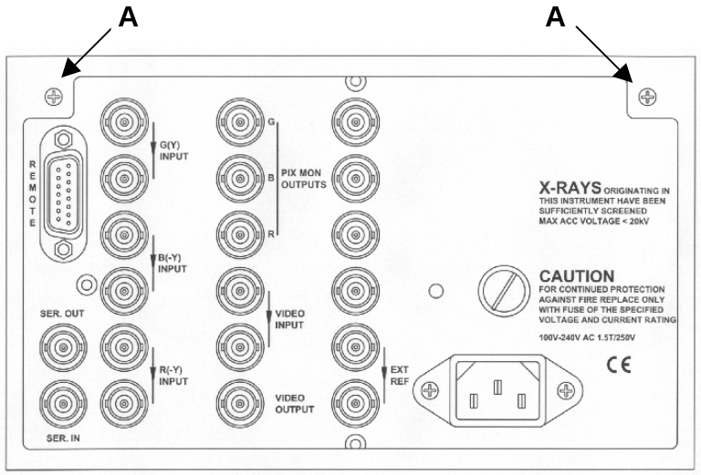

Fig. 5-1 Rearplate

Gamut indicator
The gamut indicator on the PIX MONITOR outputs can be switched on/off by replacing a programming plug on the PIX monitor unit.
From the factory is the PT 5664 delivered with gamut on.

To change the setting please use the following procedure:
- Open the instrument as shown in section 5.4.2
- Place the programming plug PP1 according to fig. 5-2

External reference input
The external reference input may be modified from 150-400mV to 4V sync signal by selecting a 10:1 division circuit on/off. This is done by replacing a programming plug on the control board unit.
From the factory is the PT 5664 delivered with the programming plug in position 150-400mV sync signal.

To change the setting please use the following procedure:
- Open the instrument as shown in section 5.4
- Place the programming plug PP2 according to fig. 5-2

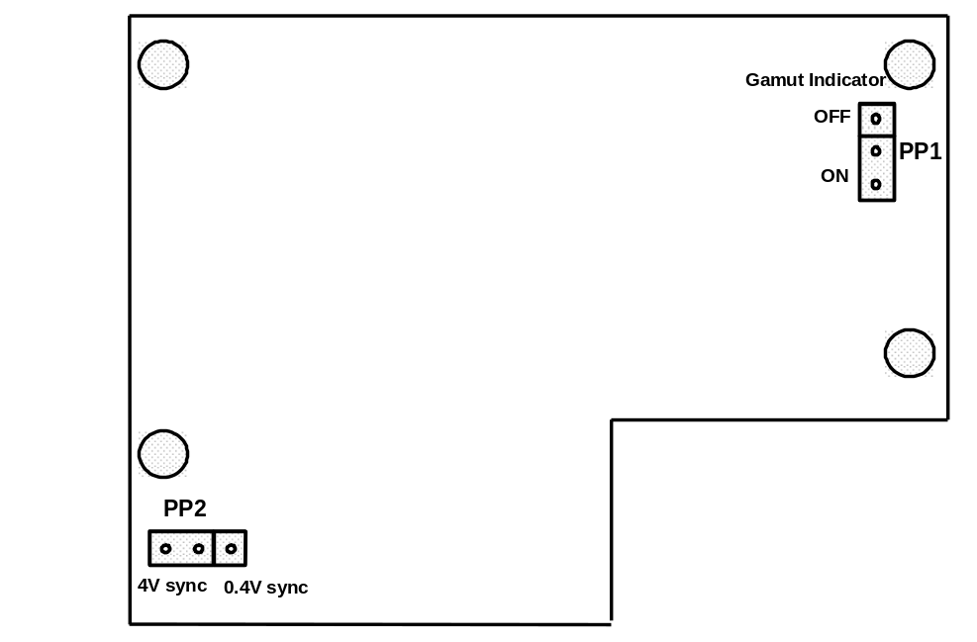

Fig 5-2 Location of jumpers

Rack mounting
This instrument is delivered either in a 19” cabinet or without cabinet for mounting in other compatible enclosures. In table top use, the free air convection is sufficient for cooling.
In systems where the instrument and other equipment are mounted in a 19” rack, special attention must be paid to the temperature. To avoid overheating, we recommend the following solutions:

Free air convection
Mount an air-flow unit (e.g. type PM 9799) between or underneath the cabinets. The dimensions of this unit is 1U high (=4.5 cm/1¾”) and 19” wide.

Forced circulation
Where forced convection is applied, f. inst. by ventilation fans in the top or bottom of the rack, care should be taken to have air flowing through the instrument.

Operating Instructions

Front panel controls
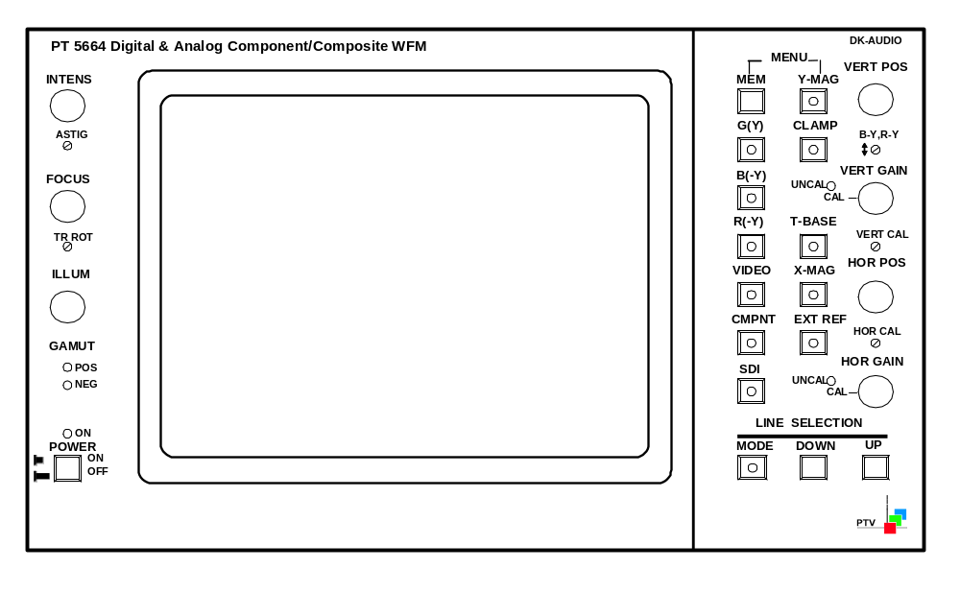
Fig. 6-1 Front of instrument

“POWER” – Mains switch
ON when pressed.
OFF when released (green band showing).
“ON”:
Pilot lamp indicates the ON state of the power instrument.
“ILLUM”
Continuously variable control of the graticule illumination.
“FOCUS”
Allows the beam to be focused for minimum spot size.
“INTENS”
Continuously variable control of the trace intensity.
“ASTIG”
Astigmatism control. Interacts with the FOCUS potentiometer.
“TR ROT” – Trace Rotation
Screwdriver control for aligning the trace in parallel with the horizontal graticule lines.
“GAMUT”
Gamut error detection.
POS LED goes on when the signal is above the legal RGB value +5% (735mV ±5mV).
NEG LED goes on when the signal is below the legal RGB value – 5% (-35mV ±5mV).
“MEM” – Memory
By pressing this button, it is possible to select one function set-up.
For storing set-up, see Chapter 7, Item 7.11.
“MENU”
Pressing these two buttons (MEM & Y-MAG) simultaneously gives access to the main-menu and all sub-menus.
“G(Y)” – Green or Y component
With this button the G(Y) component can be switched on/off (analog or SDI)
“B(-Y)” – Blue or B-Y component
With this button the B(-Y) component can be switched on/off (analog or SDI).
“R(-Y)” – Red or R-Y component
With this button the R(-Y) component can be switched on/off (analog or SDI).
“VIDEO” – Composite video
With this button the composite video can be switched on/off.
If VIDEO is selected in Waveform mode when one or more component already are selected, the external video signal will be displayed with the “first” (Priority row: G(Y), B(-Y), R(-Y)) selected component signal overlaid. When VIDEO is switched off again, the monitor will return to the previous component selection.
If VIDEO is selected in Parade mode, the external video signal will be displayed in the left part of the display with the last selected component in the right part of the display.

“CMPNT” – Analog Component input
With this button the analog component input is selected. When this input is selected, the SDI Input is deselected.
“SDI” - SDI Input (Serial Digital).
With this button the Serial Digital Video (SDI) input is selected. When this input is selected, the CMPNT (analog component) input is deselected (i.e. G(Y), B(-Y) and R(-Y)).
“Y-MAG” – Vertical magnification.
When pressing this button the display will be magnified in the vertical direction. In Vector- and Star-mode this button simultaneously activates the horizontal magnification (X-MAG).
“CLAMP”
The switch selects clamp on/off. The clamp removes DC-content in the input without affecting hum. Depending on the display mode the button may not be operable, but the LED in the button indicates the actual status needed in the signal processing.
“T-BASE – Time base selector
With this button the up to 4 different time bases are selected: H, 2H, V, and 2V (i.e. 1 line, 2 lines, 1 field and 2 fields display). The number of time base steps depends on the selected mode.
“X-MAG” – Horizontal magnification.
When pressing this button the display will be magnified in the horizontal direction. In Vector- and Star-mode this button simultaneously activates the vertical magnification (Y-MAG).
“EXT REF” – External reference
When this function is selected (on), the signal applied to the EXT REF connector is used for synchronisation of the monitor.
When this function is de-selected (off), the sync of the displayed signal is used for synchronisation of the monitor.
“VERT POS” – Vertical beam position
Continuously variable control giving vertical shift of the display.
“B-Y, R-Y”
Level adjustment of the Blue/P_{B} and Red/P_{R} component.
“VERT GAIN” – Vertical gain
Continuously variable control of the vertical gain. When activated, the red LED “UNCAL” will be on.
“VERT CAL” – Vertical calibration
Screw driver adjustment of the vertical gain.
“HOR POS” – Horizontal beam position
Continuously variable control giving horizontal shift of the display.
“HOR CAL” – Horizontal calibration
Screw driver adjustment of the horizontal gain. In STAR, VECTOR and BOWTIE mode.
“HOR GAIN” – Horizontal gain
Continuously variable control of the horizontal gain. When activated, the red LED “UNCAL” will be on. In STAR, VECTOR and BOWTIE mode.
“LINE SELECTION”
MODE:
Activates the line selection mode, selection of Field 1, Field 2, both Fields, and de-activates the line selection mode.
DOWN/UP:
Line number selection. In Test mode VARIABLE the buttons DOWN/UP are used to select the variable set-up level.

Rear panel connections

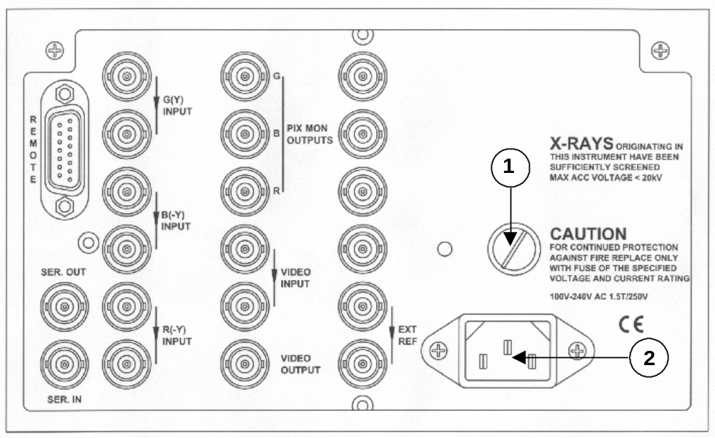

Fig. 6-2 Rear panel

1
Mains fuse

2
Mains voltage input

“SER IN”
BNC for connecting the SDI signal. The input is internally terminated into 75Ω.
“SER OUT”
BNC supplying a buffered and re-clocked SDI signal of the “SER IN” signal.
“G(Y) INPUT”
BNC connector for connecting a Green or Y component signal. The input is loop-through connected and compensated for 75Ω. If the loop-through feature is not used, the unused connector must be terminated with 75Ω.
“B(-Y) INPUT”
BNC connector for connecting a Blue or B-Y component signal. The input is loop-through connected and compensated for 75Ω. If the loop-through feature is not used, the unused connector must be terminated with 75Ω.
“R(-Y) INPUT”
BNC connector for connecting a Red or R-Y component signal. The input is loop-through connected and compensated for 75Ω. If the loop-through feature is not used, the unused connector must be terminated with 75Ω.
“EXT REF”
BNC connector for connecting an external video or sync signal as reference. The input is loop-through connected and compensated for 75Ω. If the loop-through feature is not used, the unused connector must be terminated with 75Ω.
“REMOTE”
15 pin connector for TTL-controlled operation of 7 set-up memories.
The pin configuration is as follows:
Pin 1: Internal I²C-bus (SDA). DO NOT CONNECT
Pin 2: Internal I²C-bus (SCL). DO NOT CONNECT
Pin 3: MEM R-7.
Pin 4: Not connected.
Pin 5: MEM R-5.
Pin 6: MEM R-3.
Pin 7: MEM R-1.
Pin 8: Single line pulse.
Pin 9: Ground.
Pin 10: Not connected.
Pin 11: Store.
Pin 12: MEM R-6.
Pin 13: MEM R-4.
Pin 14: MEM R-2.
Pin 15: +5 V.
“PIX MON OUTPUTS”
The PIX monitor outputs always supplies the component signals in RGB format, also when the input signal is in colour difference formats , i.e. YP_{B}P_{R}.
If RGB is applied as input format, the mounted transcoder is by-passed. Output is for monitoring purpose with 75Ω outputs.

“VIDEO INPUT”
Loop-through BNC connector for connecting a video signal. If the loop-through feature is not used, the unused connector must be terminated with 75Ω.

“VIDEO OUTPUT”
BNC connector applying the signal connected to VIDEO INPUT.

Main MENU (MODE) selection
To enter the MODE MENU, the push buttons MEM and Y-MAG (MENU) have to be pressed once simultaneously. The display will look as shown on figure 6-3 with the selected function "high lighted" by the arrow. At the same time the LED's in the relevant push buttons, below the MEM button, will light up, indicating which buttons can be used for the selection.

Now the display MODE in question can be selected by simply pressing the relevant button. If no selection is made the monitor will return to the previous mode after approximate 10 seconds. If no selection is wanted, the display can be left by selecting the MODE already indicated.

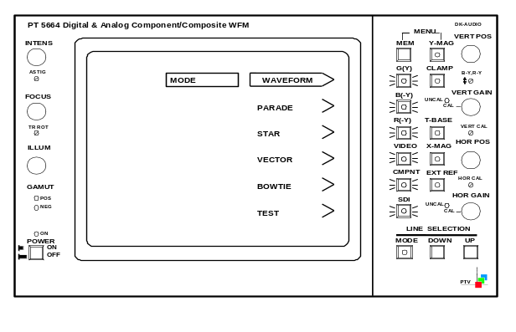

Fig. 6-3 MODE display

Input format
In the WAVEFORM, PARADE, STAR, and VECTOR mode it is possible to select the input format for the analog component signal.
Select the MODE menu and press the MEM and Y-MAG button simultaneously twice. Now the INPUT FORMAT mode enters the display (e.g. in figure 6-4).

Now it is possible to select between RGB input and Y/P_{B}/P_{R}, MII or Betacam depending on the instrument set-up.

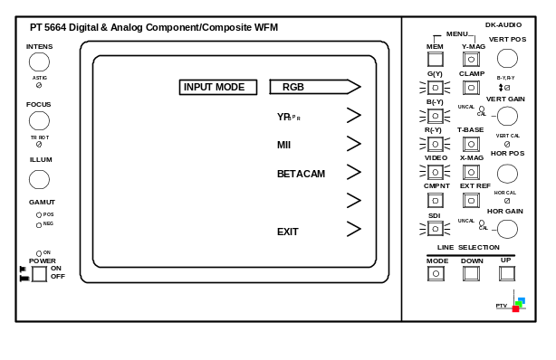

Fig. 6-4 INPUT FORMAT display

WAVEFORM display mode
The following modes can be displayed in the waveform mode:
- 1 line
- 2 lines
- 1 field
- 2 fields
These modes are selected on T-BASE button.

After the selection of “SDI” or “CMPNT” input, the component signal elements (or video signal) which is wanted for display must be selected on the G(Y), B(-Y), R(-Y), or VIDEO button. If 2 or more signals are selected they will be shown as overlaid signals.

Furthermore is possible to have a display of one single line in a frame (see section 6.10).

In the WAVEFORM mode it is possible to switch between different filters:
- “LOW PASS” - low-pass filter removes the high frequency video (or noise)
- “NON LIN” – band-pass filter used in measuring Static non-linearity (differentiating the steps of the staircase). The non-linearity measurement can only be activated when Waveform mode, Parade mode, Test-700mV mode, or Test-Variable mode is selected
- “FLAT” – no filtering is employed
The filter menu is entered by entering the MODE MENU, and pressing the MEM and Y-MAG buttons simultaneously one more time. The display will now look as figure 6-5.

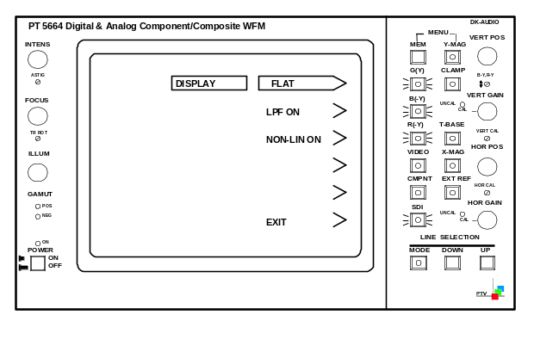

Fig. 6-5 DISPLAY mode

WFM Display format
In the WAVEFORM and PARADE display it is possible to select the actual display format. Analog YP_{B}P_{R} input or SDI input can beside their native format also be display as RGB. This function is valuable in monitoring of cameras, graphic editing. It shows immediately if colour gamut has been violated.

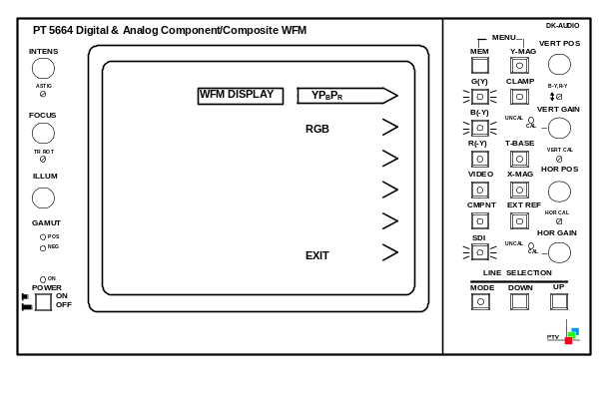

FIG 6-6 WFM display setting

PARADE display mode
The PARADE display mode offers 2 different displays:
- All three inputs side by side in the same display in the sequence left to right.
- R,G,B for RGB input signal or when display format for SDI and CMPNT is selected as
RGB
- Y,P_{B},P_{R} for direct display of SDI input and analog colour difference signals
- Video input in the left part of the screen and a selected component in the right part of the screen

The rest of the operation is identical to the waveform mode.

The colour difference components are clamped to the 50% level in the luminance/colour difference display mode.

STAR display mode
The Star display offers monitoring of timing and amplitude errors between the components of the RGB-signal, the Y/P_{B}/P_{R} or the SDI signal. The test uses an ordinary colourbar as reference signal, which reveals error with a good resolution.

Several sub-menus are available for the STAR display mode.
Pressing the MEM and Y-MAG buttons simultaneous twice will give access to the GRATICULE selection mode as shown in fig. 6-7.

Here it is possible to select the electronic graticule for either 75% or 100% colourbar, or switch off the electronic graticule with boxes of ±2% in size.
Furthermore it is possible to switch on/off (the function toggles) the small measuring dots used for checking timing errors. The measurement dots indicate 40, 80 and 160 ns of timing differences.

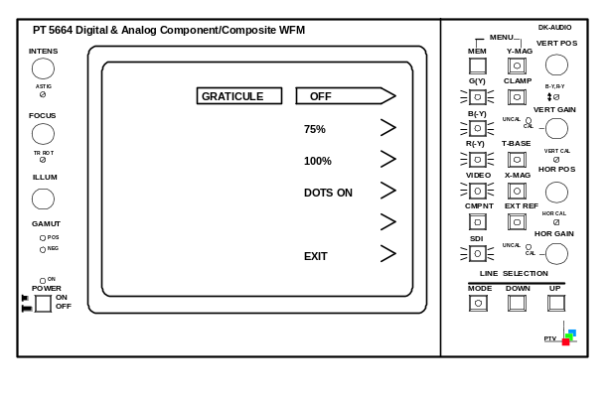

Fig. 6-7 GRATICULE selection display, Star mode

Component based signals from sources such as a VTR or camera are particularly sensitive to timing and amplitude errors in the signal path. A timing error results in coloured edges and an amplitude error results in discolouring of the picture. The STAR display in magnified mode is designed especially for the reveal of such errors. To ensure a correct alignment, the measuring dots can be switched on, to check for timing errors. (See fig. 6-8 and 6-9).

Every component can be switched off in case only two components have to be compared.

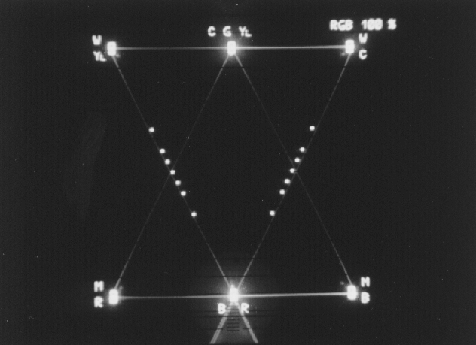

Fig. 6-8 Measuring dots, RGB mode

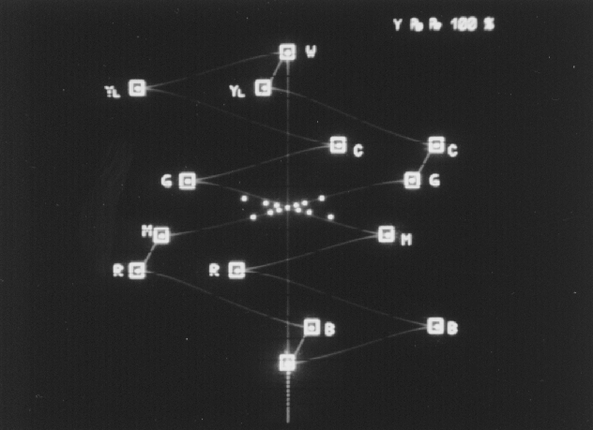

Fig. 6-9 Measuring dots, Y/P_{B}/P_{R} mode

Transcoder display
If the input format is RGB it is possible to switch on a transcoder. Select the MODE menu and press the MEM and Y-MAG buttons three times more. The TRANSCODER selection menu will be shown on the display (e.g. in figure 6-10).

With the transcoder on, the RGB input signals will be transcoded and shown as Y/P_{B}/P_{R}.

Note that with the transcoder on, the precision of the timing measurements will be slightly less accurate as without.

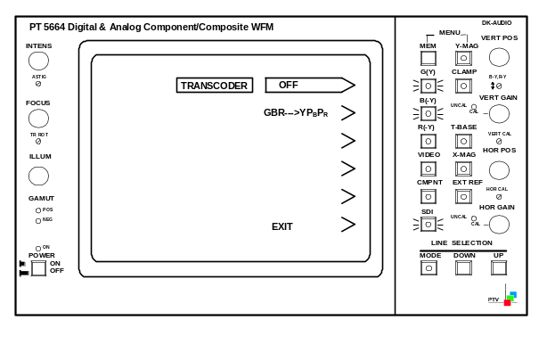

Fig. 6-10 TRANSCODER selection display

VECTOR display mode
The VECTOR mode shows the colour amplitude and phases of the incoming component signals.

When using the VECTOR mode, an electronic graticule for either a 75% or a 100% colourbar can be switched on. Pressing the MEM and Y-MAG buttons simultaneous twice will give access to the GRATICULE selection mode as shown in fig. 6-11.

Here it is possible to select the electronic graticule for either 75% or 100% colourbar, or switch off the electronic graticule.
Furthermore is possible to display a single line in a frame (See section 6.10).

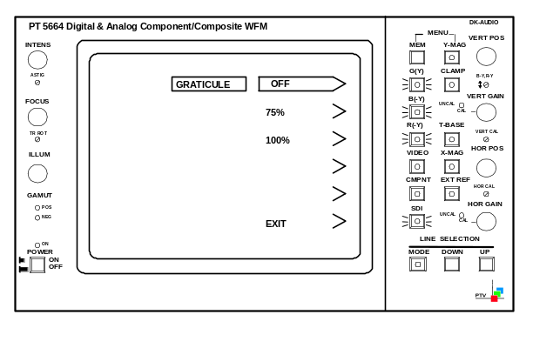

Fig. 6-11 GRATICULE selection display, Vector mode

Transcoder display
As in the Star mode it is possible to switch on a transcoder if the input format is RGB. For further menu operation see section 6.6.1.

TEST GRID facilities
When selecting the GRATICULE selection menu it is possible to select a TEST GRID function. This function offers three different test facilities.

NOTE:
To achieve a useable display, the intensity of the INPUT signal (INTENS) should be turned down fully.

- Beam accuracy check (see figure 6-12).
The shown square (largest one) contains four horizontal lines representing each a level. The lower line represents a level of -30%, the next line equals to 0%, the third line from the bottom represents a level of 40% and the upper line represents a level of 110%. These four lines should match with the same level marks on graticule of the CRT, to ensure that the signal level is displayed correct. A vertical off-set of ±4% can be tolerated.

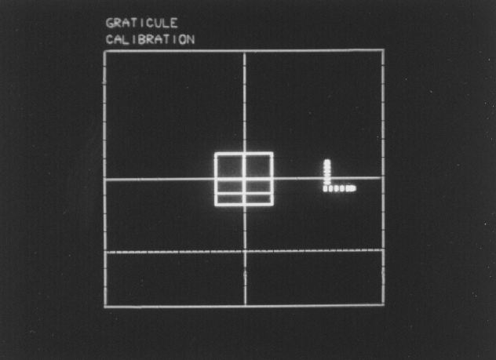

Fig. 6-12 Test grid, beam accuracy check

- X/Y-magnification check (see figure 6-13).
To check whether the magnification is within the legal limits, the Y-MAG or X-MAG button has to be pressed. Now it is possible to match the two squares using the VERT POS and HOR POS potentiometers on the front panel. The size of the two "squares" should be identical, with one beam width as maximum tolerance

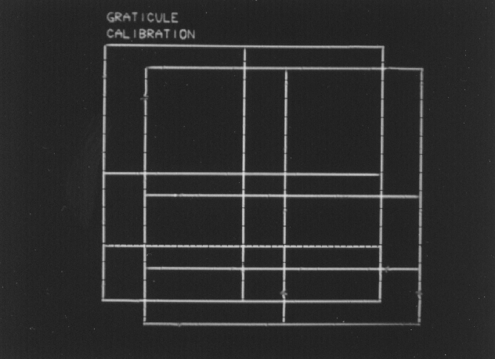

Fig. 6-13 Test grid, X/Y-magnification check

- D/A-converter check (see figure 6-14).
To check whether the D/A-converter is converting correctly, the Y-MAG or X-MAG button has to be pressed. By moving the horizontal position to the left, a horizontal and vertical "arrow" will appear on the display. Each arrow consists of six small waves, which represent the six lowest bits in the horizontal and the vertical direction. The magnitude of each wave should be twice the size of the previous wave (starting from the lower left). The vertical and horizontal waves in the same "bit"-position should be identical in magnitude.

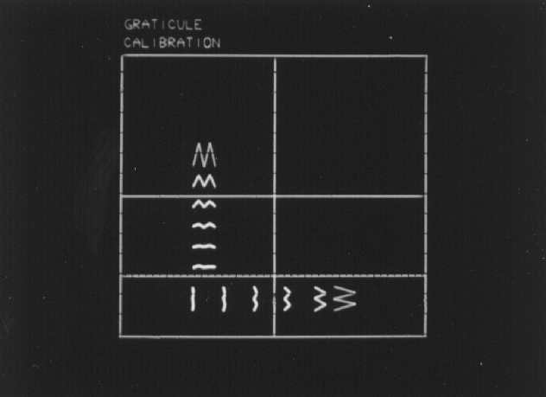

Fig. 6-14 Test grid, D/A-converter check

BOWTIE display mode
The BOWTIE mode is used to align studio systems for amplitude and timing. For this a special test signal is needed, which then will indicate the relative amplitudes and relative timing on the monitor. The test signals applied are a 500kHz sinewave signal applied to the G(Y)-input and a 502kHz sinewave signal applied to the R(-Y)-input and the B(-Y)-input. The monitor makes a subtraction and shows in the left part of the display G(Y)-B(-Y), and G(Y)-R(-Y) in the right part of the display.

The 502kHz signal, applied at the B(-Y)- and R(-Y)-inputs, is generated in a way, so that it is in phase with the 500kHz signal, applied at the G(Y)-input, in the centre of the signal.
Equal amplitude is therefore obtained when the centre of the "butterfly" is zero (see figure 6-15). Amplitude errors will be seen as a raise of the centre-point.
Correct timing is obtained when the centre of the "butterfly" is located at the tallest "marker pin" (see figure 6-15). Timing errors can be measured directly since each "marker pin" corresponds to a timing interval of 20 nanoseconds.

X- and Y-magnification can be operated in the BOWTIE mode to increase the precision of the measurements.

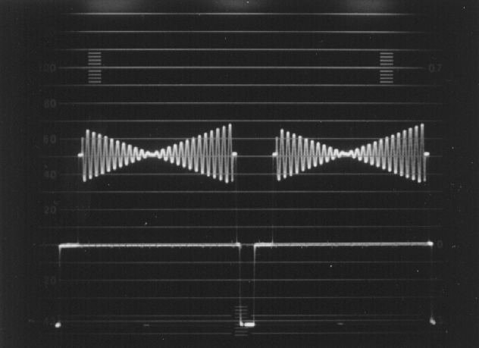

Fig. 6-15 BOWTIE signal

TEST mode
In TEST mode the PT 5664 offers several facilities for calibration purpose. A survey is found in the CALIBRATE menu. This menu is automatically obtained when TEST is selected in the MODE menu.

NOTE:
When selecting a test facility, the monitor will remain in this mode until another mode is selected in the MODE menu.

Following test facilities are available:
- 700mV
This function shows a steady indication of the 700mV level. This function shows the incoming video signal twice:
- As normal waveform display and
- As an overlaid signal with 700mV offset.
The 0-line of the offset signal indicates the 700mV level. The V/2V function can not be operated in this mode.

- VARIABLE
Indicates a selected level on the display. This function shows the incoming video signal twice:
- As normal waveform display and
- As an overlaid signal with variable offset.
The offset can be selected by means of the UP and DOWN buttons in the Line selection part on the front panel. The offset can be varied from -500mV to +1500mV. The 0-line level of the overlaid (offset) signal is shown in mV in the upper left corner of the screen.

- 100kHz
To check the horizontal timing and the vertical deflection in Waveform mode, a 100 kHz square wave signal with an amplitude of 1V_{PP} is provided from an internal generator.

- G(Y) & EXT ALT
This mode offers a waveform display of the G(Y) component signal alternating with the external reference signal. This gives the possibility to check the timing between the two signals. Note that the signals has to locked together and timing difference not greater than one line.

- G(Y) – EXT
This mode offers a waveform display of the subtraction between the G(Y) component and the external reference signal. The feature offers the possibility to check the timing between the two signals. Note that the signals has to locked together and timing difference not greater than one line.

- EXT
Shows the signal applied at the EXTERNAL REF connector.

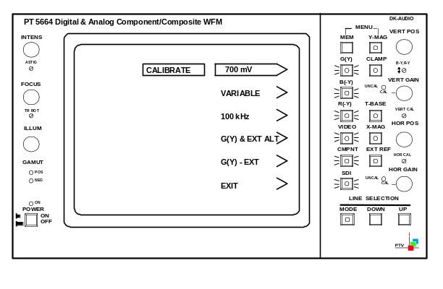

Fig. 6-16 TEST mode sub-menu

Line selection

General
In the WAVEFORM and the VECTOR mode it is possible to select display of a single line of the signal.

The line selector function is activated by pressing the MODE button once. The selected line- (and field-) number is shown in the upper left corner of the display.
A second press on the MODE button will make the instrument switch to the equivalent line in field 2.
A third press on the mode button will make the instrument show the equivalent lines of both field 1 and 2 at the same time.
A fourth press on the MODE button will switch off the line selection mode again.

The wanted line number can be found by pressing the UP or DOWN buttons. One push selects the next line. Continuous pressing of the UP or DOWN button will activate a scroll function

If the UP or DOWN button are pressed and the next line number in question will exceed the relevant line numbers of the field, the monitor automatically switches to the other field.

Please pay attention to the following notes:
- The line selection function can only be activated in the WAVEFORM and the VECTOR mode.

- If the TV system applied to the monitor is a non-interlaced system (e.g. 524 lines or 624 lines), it will be indicated by "NI" after of the line number when line selection mode is activated, and the field that is selected as field 1 is random.

- Correct function of the line counter in single line mode can only be guaranteed when either sync is applied on the incoming signal or an external reference is applied.

- In case the TV system applied to the monitor (e.g. 625 lines to 525 lines) is changed without turning the monitor off, one of the three buttons in the line selection part (MODE, UP, or DOWN) must be pressed once to obtain correct operation of the line counter.

Waveform mode
As mentioned earlier the WAVEFORM mode can offer display in:
- 1 line
- 2 line
- 1 field
- 2 field-mode.

When a 2-line display is selected the "left line" is the one which is indicated in the upper left corner.
When the 1- or 2 field function is selected, the selected line(s) will be highlighted on the signal display.
The line-number indication in the upper left corner of the display is not activated when the 2-field (2V) function is selected or if both lines are selected in the 1-field (V) display.

Please note that only one component (or the video input signal) can be shown at the time when the line selection mode is activated.

Vector mode
In the VECTOR mode only two components (B(-Y), R(-Y)) can be shown (at the same time).

Gamut error detection
Monitoring of the Gamut range ensures that no illegal colour can occur without a warning is released. A Gamut error occurs when a primary colour component level exceeds the limits of 735mV in the upper range and -35mV in the lower range. This error is made visible by two LEDs on the front panel of the instrument, and on the PIX MON OUTPUTS as a flickering area on the monitor screen displaying the error area.
To avoid extremely short transients to trigger to gamut detection a low-pass filter is inserted. This filter has a bandwidth of approximately 1 MHz.

NOTE:
The PT 5664 is supplied with the Gamut error indication on the PIX Monitor outputs on.

Master reset of the PT 5664
In case some electrical interruptions make it impossible to operate the instrument or the set-up is to be changed fully, a master reset function is available.
Reset is performed as follows:
- Switch the instrument off
- Keep the R(-Y) button pressed and switch the instrument on

After the reset the instrument will return to the following default set-up:

General:
- Analog Component input selected
- Clamp on
- G(Y) selected
- LP-filter off
- Y/P_{B}/P_{R}-format selected
- Internal sync

WAVEFORM mode:
- 2 H

PARADE mode:
- 2 H

STAR mode:
- 75% graticule
- Dots off

VECTOR mode:
- 75% graticule

TEST mode:
- Variable test voltage: 0 mV

Furthermore is WAVEFORM mode selected as MEM 1 and VECTOR mode selected as MEM 2.

NOTE:
The set-up of the remote controlled MEM-functions will not be reset.

Memory functions
The PT 5664 is equipped with two presets available from the front panel: one is user programmable and one is default switching to Vectorscope mode.
From the REMOTE connector 7 set-up memories are available.

Front panel controlled memories
Two different front panel set-up's may be recalled from each a memory (MEM 1 and MEM 2), controlled via the MEM button on the front panel. The monitor toggles between the two presets when the MEM button is pressed.

NOTE:
Only main modes are stored, not the settings of f. inst. low-pass filter, modification to displays, etc.

Storing a set-up:
- Select mode to be stored:
- Press the two buttons MEM and Y-MAG (MENU) simultaneously
- Select mode from the Menu list
- Enter STORE mode
- Press the two buttons MEM and Y-MAG (MENU) simultaneously (Menu is shown now)
- Press the two buttons MEM and Y-MAG (MENU) simultaneously , and while keeping pressed press button for MODE just selected
- Release buttons MEM and Y-MAG (MENU) before of releasing the button for the MODE
The selected mode and set-up is now stored.

The MEM button now toggles between the User defined mode and the Vector mode

NOTE:
The position of the potentiometers can not be stored.

Remote controlled memories
The PT 5664 is equipped with a TTL remote control, which gives access to other 7 memories. Each memory is recalled when the appropriate pin on the REMOTE connector is (shortly) connected to ground.

For pin configuration of the REMOTE connector please see section 6.2 Rear panel connections

Storing a set-up:
- Select on the front panel the mode and set-up you want to store
- Connect pin 11 (Store) to ground (pin 9)
- Connect the pin in question for the selected memory shortly to ground
- Disconnect the ground from pin 11 (Store). The selected mode and set-up is now stored

END OF DOCUMENT

